Agentic AI Applications with Claude Code
Practical Performance Assessment

A: Trainee Information:

Trainee Name (as Per NRIC): ____NG YEW SENG___________________________

Last 3 digits and alphabet of NRIC/FIN: _____353F____________

Date: __17/4/2026________________

B: Instruction to Candidates

1. This is an individual exercise
2. This is an open book assessment
3. A total of 1 hr is given to complete the written assessment
4. Submit your answers on the document provided

C. Practical Performance

Scenario
A training consultancy has been engaged by a mid-sized company to rapidly develop and launch a simple customer self-service web application within a tight timeline. As part of the project, the developer is required to use Claude Code to quickly vibe code the application, version it properly using GitHub, and deploy it to a cloud platform for public access. To ensure quality and reliability, the developer must then use the Playwright MCP tool to perform automated testing of key user flows and document the results by adding screenshots to the project’s GitHub README. Finally, to enhance user experience and align with modern UI standards, a specialized UI sub-agent is created to iteratively refine and improve the application’s interface, ensuring it is visually appealing, responsive, and user-friendly.
Task 1 Vibe code a web app using Claude Code and deploy on the cloud. (A1)

Paste a screenshot of your setup and outputs here
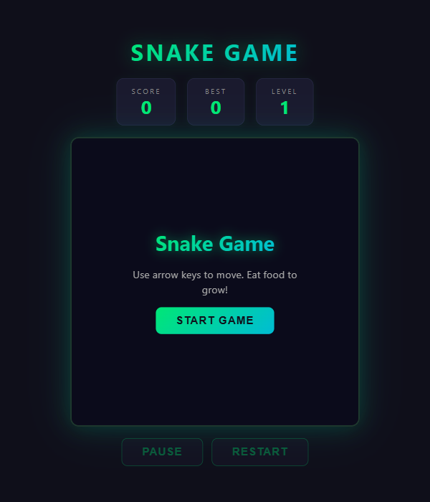

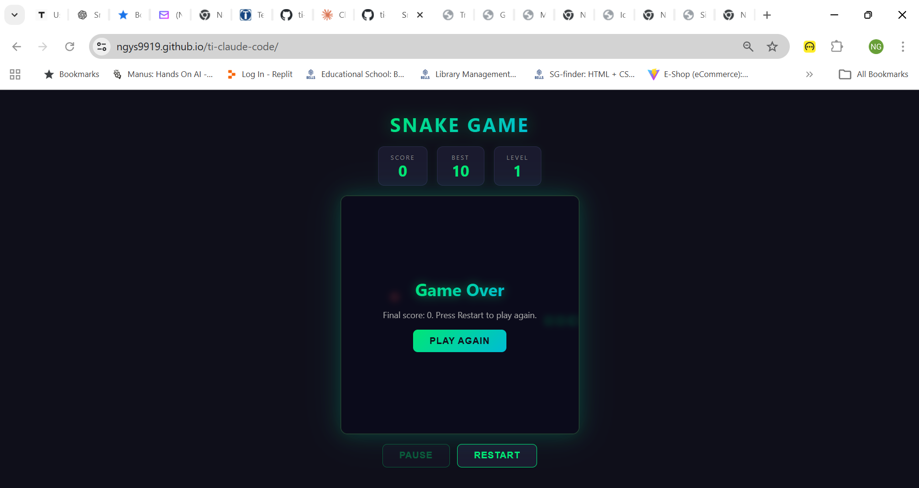

Task 2: Use Playwright MCP tool to test your web app and add a screenshot to the readme in Github
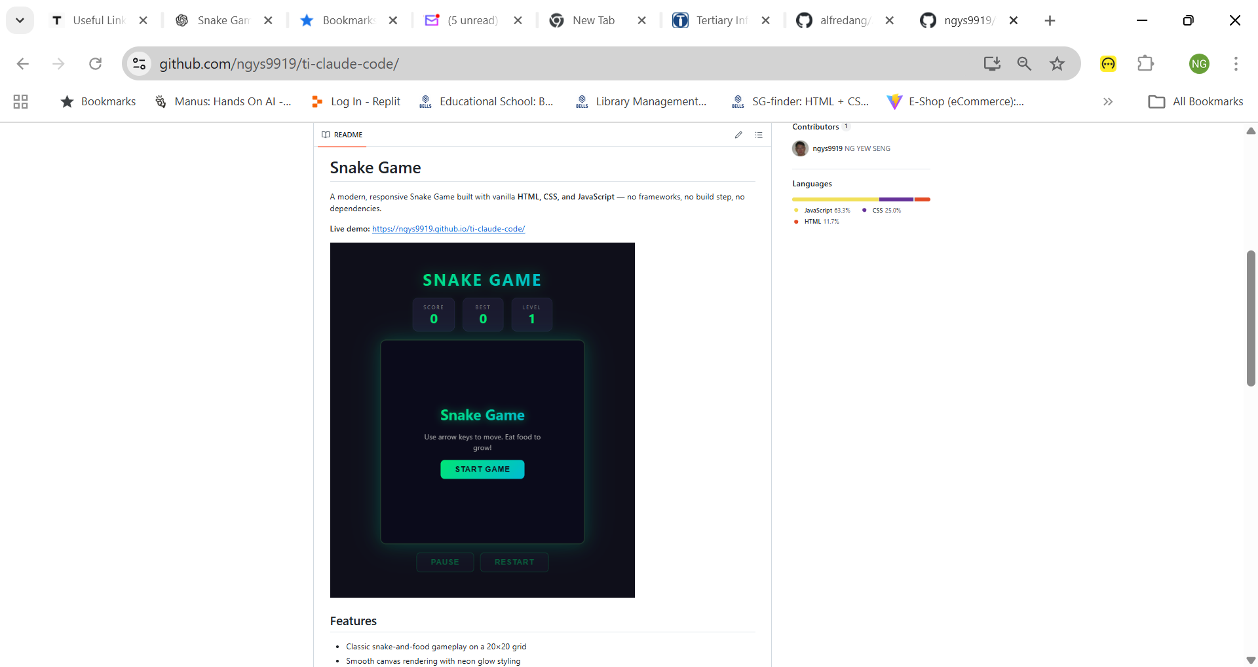

Task 3:Create UI sub agent to improve the UI of your web app

Paste a screenshot of your setup and outputs here
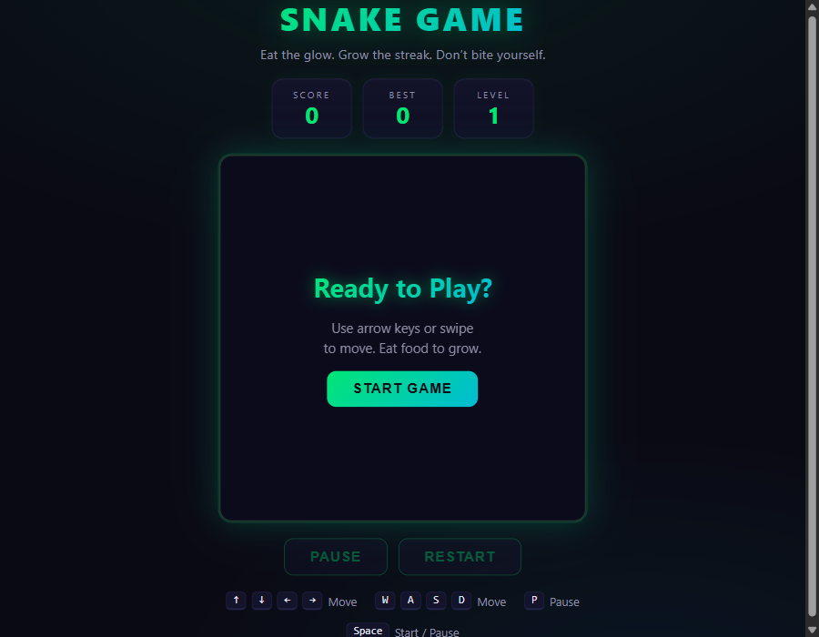

_____________________________________________________________________________
For Official Use Only

Candidate has successfully completed all the tasks for PP and is able to explain the overall functions and features used to achieve these tasks.

Grade: _____ (C / NYC)

Assessor Name: _______________ Assessor NRIC: _____________

Date: ________________________ Signature: _________________

Please create a subfolder named YYYY-MM-DD/DD_<<Trainer Name>> and upload all the learner's assessments to the respective Google Drive.
Please email support@tertiarycourses.com.sg after you have uploaded the assessment.

